##### A Project report on

**Chat KCR- Your AI Interviewer For Technical/HR Brilliance**

###### A Dissertation submitted to JNTU Hyderabad in partial fulfillment of the academic requirements for the award of the degree.

**Bachelor of Technology**

**in**

**Computer Science and Engineering**

Submitted by

Kala Kushal Jain

(20H51A0534)

G. Rama Sai Charan

(20H51A0593)

Rahul Sai Ranganathan

(20H51A05J4)

Under the esteemed guidance of

Major Dr. V.A. Narayana

(Professor of CSE & Principal)

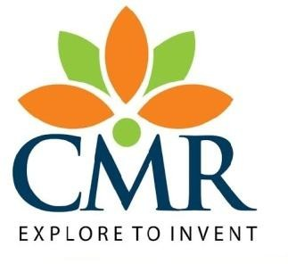

**Department of Computer Science and Engineering**

**CMR COLLEGE OF ENGINEERING & TECHNOLOGY**

(UGC Autonomous)

*Approved by AICTE *Affiliated to JNTUH *NAAC Accredited with A+ Grade

KANDLAKOYA, MEDCHAL ROAD, HYDERABAD - 501401.

#### 2020- 2024

**CMR COLLEGE OF ENGINEERING & TECHNOLOGY**

KANDLAKOYA, MEDCHAL ROAD, HYDERABAD – 501401

**DEPARTMENT OF COMPUTER SCIENCE AND ENGINEERING**



#### CERTIFICATE

This is to certify that the Major Project Phase I report entitled **"Chat KCR- Your AI Interviewer For Technical/HR Brilliance"** being submitted by Kala Kushal Jain(20H51A0534), G. Rama Sai Charan (20H51A0593), Rahul Sai Ranganathan (20H51A05J4) in partial fulfillment for the award of **Bachelor of Technology in Computer Science and Engineering** is a record of bonafide work carried out his/her under my guidance and supervision.

###### The results embodies in this project report have not been submitted to any other University or Institute for the award of any Degree.

**Major Dr. V.A. Narayana Dr. Siva Skandha Sanagala**

**Professor of CSE & Principal Associate Professor and HOD**

**Dept. of CSE**

#### ACKNOWLEDGEMENT

With great pleasure we want to take this opportunity to express my heartfelt gratitude to all the people who helped in making this project work a grand success.

We are grateful to **Major Dr. V.A. Narayana ,** Professor , Department of Computer Science and Engineering & Principal for his valuable technical suggestions and guidance during the execution of this project work.

We would like to thank **Dr. Siva Skandha Sanagala,** Head of the Department of Computer Science and Engineering, CMR College of Engineering and Technology, who is the major driving forces to complete my project work successfully.

We are very grateful to **Dr. Vijaya Kumar Koppula**, Dean-Academics, CMR College of Engineering and Technology, for his constant support and motivation in carrying out the project work successfully.

We are highly indebted to **Major Dr. V A Narayana,** Principal, CMR College of Engineering and Technology, for giving permission to carry out this project in a successful and fruitful way.

We would like to thank the **Teaching & Non- teaching** staff of Department of Computer Science and Engineering for their co-operation

We express our sincere thanks to **Shri. Ch. Gopal Reddy**, Secretary, CMR Group of Institutions, for his continuous care.

Finally, We extend thanks to our parents who stood behind us at different stages of this Project. We sincerely acknowledge and thank all those who gave support directly and indirectly in completion of this project work.

Kala Kushal Jain 20H51A0534

G. Rama Sai Charan 20H51A0593

Rahul Sai Ranganathan 20H51A05J4

Chat KCR-Your AI Interviewer For Technical/HR Brilliance

**TABLE OF CONTENTS**

**CHAPTER NO TITLE PAGE NO.**

LIST OF FIGURES i

ABSTRACT ii

**1** **INTRODUCTION** 1

1.1 Problem Statement 2

1.2 Research Objective 2

1.3 Project Scope and Limitations 3

**2** **BACKGROUND WORK** 4

2.1. Interview Bot Development with NLP and ML 5

2.1.1 Introduction 5

2.1.2 Merits, Demerits and Challenges 6

2.1.3 Implementation 7

2.2. Chatbots In HR, Study & Future of AI 8

2.2.1 Introduction 8

2.2.2 Merits, Demerits and Challenges 9

2.2.3 Implementation 9

2.3. Chatbots as a Game Change in E-recruitment 10

2.3.1 Introduction 10

2.3.2 Merits, Demerits and Challenges 11

2.3.3 Implementation 11

**3 RESULTS AND DISCUSSION** 13

4 **CONCLUSION** 14

5.1 Conclusion 15

5 **REFERENCES** 17

CMRCET B. Tech (CSE)

Chat KCR-Your AI Interviewer For Technical/HR Brilliance

**LIST OF FIGURES**

**FIGURE NO. TITLE PAGE NO.**

2.1 Implementation of Interview Chatbot with NLP & ML 8

2.2 Implementation of Interview Chatbot by NLU 11

CMRCET B. Tech (CSE) i

Chat KCR-Your AI Interviewer For Technical/HR Brilliance

# **ABSTRACT**

Acing interviews demands a blend of solid technical skills and adept interpersonal abilities. Recognizing this crucial aspect, we are embarking on the development of an innovative interview simulation chatbot. This chatbot will assume the persona of an interviewer, offering users a unique opportunity to assess and refine their capabilities. Through interactive engagement, users can gauge their technical expertise and gain familiarity with the subtleties of real-world interview scenarios, where the chatbot's questions will be dynamically tailored based on the answers given by the user.

By Leveraging advanced Natural Language Processing (NLP) and Machine Learning (ML) algorithms, we will seamlessly integrate these technologies throughout the chatbot's developmental journey. From scrutinizing user text to constructing detailed data models and dynamically tailoring questions based on user input, NLP and ML will constitute the foundation of the chatbot's functionality. Featuring an intuitive user interface accessible via web application, the chatbot will facilitate effortless interaction. This will aid users in appraising and improving their technical and communication skills, effectively preparing them for real interview situations.

CMRCET B. Tech (CSE) ii

Chat KCR-Your AI Interviewer For Technical/HR Brilliance

# **CHAPTER 1**

**INTRODUCTION**

CMRCET B. Tech (CSE) 1

Chat KCR-Your AI Interviewer For Technical/HR Brilliance

**CHAPTER 1**

**INTRODUCTION**

**1.1 Problem Statement**

In today's competitive job market, many students and professionals lack awareness of real-time interview processes, including the types of technical and interpersonal questions asked, including questions related to projects. This knowledge gap can hinder their confidence and performance in interviews, potentially affecting their career prospects. Additionally, individuals often struggle to navigate and respond effectively to the series of questions asked throughout the interview process.

Furthermore, the challenge of not receiving interview feedback in real-time compounds the issue, as individuals are often left without immediate insights to improve. The overall challenge lies in providing an effective solution to bridge this knowledge gap, empower individuals to become better prepared for real interviews, offer timely interview feedback for continuous improvement, and guide them in addressing the full range of questions posed during the interview.

**1.2 Research Objective**

**Technical Assessment**: Develop an AI system for assessing candidates' technical skills, including programming and problem-solving abilities.

**Interpersonal Assessment:** Design a chatbot to evaluate candidates' interpersonal skills using natural language processing and sentiment analysis.

**Customization:** Implement a feature for tailoring assessment criteria to organizations' unique hiring needs.

**Feedback Generation:** Create a system that generates comprehensive feedback reports for candidates and hiring managers.

**Validation and Accuracy:** Ensure the chatbot's assessment capabilities are rigorously validated against real-world interview outcomes, focusing on accuracy and reliability.

CMRCET B. Tech (CSE) 2

Chat KCR-Your AI Interviewer For Technical/HR Brilliance

**1.3 Project Scope and Limitations**

**Scope:**

**Language Proficiency:** Assess a wide range of language skills, including grammar and vocabulary.

**Automated Interviewing:** Conduct interviews and evaluate responses in real-time.

**Content Generation:** Generate detailed feedback and reports based on candidate interactions.

**Customization:** Adapt to specific job roles, industries, or organizational needs.

**Limitations:**

**Bias and Fairness**: Chatbot may inherit biases from training data, impacting fairness in assessments.

**Limited Non-Verbal Analysis:** Inability to assess body language and tone affects interpersonal skills evaluation.

**Inaccurate Technical Assessments:** May not comprehensively evaluate complex technical skills.

**Resource-Intensive:** Developing and maintaining chatbots demands significant computational resources and expertise.

|  |
| --- |
|  |
|  |  |

  CMRCET B. Tech (CSE) 3

Chat KCR-Your AI Interviewer For Technical/HR Brilliance

**CHAPTER 2**

**BACKGROUND WORK**

CMRCET B. Tech (CSE) 4

Chat KCR-Your AI Interviewer For Technical/HR Brilliance

**CHAPTER 2**

**BACKGROUND WORK**

**2.1 Interview Bot Development with Natural Language Processing and**

**Machine Learning**

**2.1.1 Introduction**

The Indonesian government recognizes the importance of competencies for organizations to stay competitive and has introduced regulations to encourage employee skill development. These regulations, including the National Work Competency Standardization System, necessitate regular competency assessments by organizations. While Behavioral Event Interviews (BEI) have been effective for assessing competencies, they have drawbacks such as time consumption and the need for certified interviewers. To address these challenges, the use of chatbots and automation technology in HRM, especially in the interview process, is proposed. Chatbots can act as interview substitutes, conduct remote interviews, reduce costs, and offer flexibility, leveraging the benefits of AI-driven solutions.

Additionally, the development of chatbots for competency assessments is discussed. These chatbots, which interface with users through natural language, have proven efficiency and scalability. By incorporating AI technologies like machine learning and natural language processing, chatbots can generate questions interactively, improving competency assessments, reducing interviewer bias, and accommodating the changing interview landscape due to the pandemic. This research focuses on a text-based interview bot algorithm for competency assessment in the Indonesian language, representing an innovative approach to enhance competency evaluations in organizations.

**2.1.2 Merits, Demerits and Challenges**

Merits:

* Efficiency: Interview bots can significantly reduce the time required for competency assessments. They can conduct interviews simultaneously, saving both the interviewer's and interviewee's time.

|  |
| --- |
|  |
|  |  |

 CMRCET B. Tech (CSE) 5

Chat KCR-Your AI Interviewer For Technical/HR Brilliance

* Cost-Effective: Automation through interview bots can lead to cost savings in terms of- human resources and logistics. Organizations can reduce the need for certified interviewers and streamline the assessment process.
* Objectivity: Interview bots provide objective and consistent assessments, minimizing potential interviewer bias and subjectivity. This can lead to fairer evaluations of competencies.

Demerits:

* Language Limitations: Developing interview bots for languages without a past tense, such as Indonesian, can be challenging. The language's unique structure may require more complex NLP techniques.
* Lack of Human Interaction: Interview bots lack the personal touch and rapport-building abilities of human interviewers. They may struggle to gauge non-verbal cues and emotional responses accurately.
* Technical Challenges: Maintaining the accuracy and reliability of interview bots, as well as dealing with technical issues during interviews, can be a drawback.

Challenges:

* NLP Complexity: The NLP implementation in languages with unique structures demands advanced linguistic analysis and modeling, adding complexity to bot development.
* User Acceptance: Ensuring that interviewees are comfortable with and trust the assessment process conducted by bots is a significant challenge.
* Data Security: Safeguarding interviewee data and ensuring its confidentiality is crucial, especially in a bot-driven assessment environment.

|  |
| --- |
|  |
|  |  |

  CMRCET B. Tech (CSE) 6

Chat KCR-Your AI Interviewer For Technical/HR Brilliance

**2.1.3 Implementation**

The development of an interview bot for Behavioral Event Interviews (BEI) in Indonesian

presents a unique language challenge, lacking a past tense. Joko, Siswanto, and Suakanto in [1]. have previously worked on the development of an interview chatbot with natural language processing and machine learning, this bot aims to efficiently assess competencies, making the interview process cost-effective and objective. It includes facial monitoring via a camera, enabling real-time competency assessment. The development follows three stages: introduction, competency assessment, and validation, mirroring the BEI process. Introduction creates a comfortable atmosphere and includes preliminary validation questions. Competency assessment employs open questions, with the system recording, analyzing, and providing competency levels based on an algorithm. In the validation stage, interviewees view their competency descriptions and can accept or raise concerns, emphasizing data confidentiality.

The bot's development adheres to standard AI engineering processes, encompassing training to establish a competency level model and testing and evaluation to refine the model for predicting competency levels. In the initial Natural Language Processing (NLP) implementation, Indonesian sentences are tokenized, cleaned, and reduced to eliminate irrelevant elements, followed by stemming to transform words into basic forms. Part-of-speech tagging assigns roles to words within sentences, with verbs weighted the highest. Term frequency (TF) is computed for keywords, with more frequent words assigned greater weight, forming a basis for the training process. The applied model stores TF results and competency-specific words, essential for the training process and subsequent evaluation.

|  |
| --- |
|  |
|  |  |

  CMRCET B. Tech (CSE) 7

Chat KCR-Your AI Interviewer For Technical/HR Brilliance

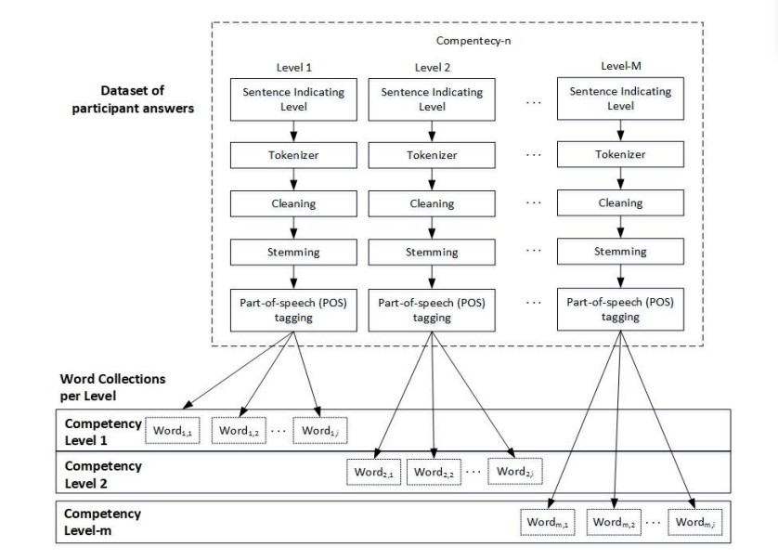

Figure 2.1: Implementation of Interview Chatbot with NLP & ML

**2.2 Chatbots In HR, Study & Future of AI**

**2.2.1 Introduction**

In an era of rapid globalization and technological advancement, technology has permeated every aspect of human life, simplifying tasks, and connecting the world. Fostering innovation is vital in a competitive business environment, with human resources playing a central role in realizing business visions. Artificial Intelligence (AI) is a pivotal force, replicating human intelligence through computer-based machines. Chatbots, AI-driven conversational agents, streamline Human Resources functions, making interactions more efficient.

This study explores Chatbots' multifaceted scope, their value, utilization, and implications for the business world's future. Chatbots have gained prominence as transformative innovations that enhance the productivity and efficiency of human resources, providing organizations with innovative tools and technologies to thrive in an interconnected world.

**2.2.2 Merits, Demerits and Challenges**

Merits:

* Enhanced Efficiency: Chatbots are available around the clock, ensuring instant queries

|  |
| --- |
|  |
|  |  |

 CMRCET B. Tech (CSE) 8

Chat KCR-Your AI Interviewer For Technical/HR Brilliance

and providing rapid solutions to HR-related issues. This uninterrupted availability translates into enhanced operational efficiency.

* Cost Savings: Automating routine HR tasks through Chatbots reduces the need for extensive human intervention, resulting in substantial cost savings.

Demerits:

* Lack of Human Touch: The absence of human interaction can sometimes lead to a perceived lack of empathy or understanding when dealing with sensitive HR matters.
* Technical Limitations: Chatbots may not always fully comprehend nuanced or complex queries and could provide inaccurate responses.

Challenges:

* Continuous Learning: Chatbots need to continually improve their language processing and problem-solving capabilities to handle a wide range of HR queries effectively.
* Integration: Seamless integration with existing HR systems and processes is essential for ensuring Chatbots deliver optimal results.

**2.2.3 Implementation**

Manasa J. and Anu Revamma Parvathi in [2] have previously researched the future of artificial intelligence: chatbots in HR. The successful implementation of Chatbots in HR relies on leveraging advanced technologies such as NLP, NLU, and machine learning techniques like Random Forest. This comprehensive plan begins by defining clear objectives for Chatbot integration within HR, such as automating responses, streamlining onboarding, and providing employee assistance. The choice of a development platform supporting NLP, NLU, and machine learning integration is crucial.

Robust data integration is established between the Chatbot and HR systems to access relevant information, while machine learning, especially Random Forest, trains the Chatbot for accurate responses. User interface design focuses on accessibility, and data security measures are implemented for compliance. Continuous monitoring and feedback-driven updates maintain the Chatbot's performance, and integration with other HR technologies is a priority.

|  |
| --- |
|  |
|  |  |

CMRCET B. Tech (CSE) 9

Chat KCR-Your AI Interviewer For Technical/HR Brilliance

**2.3 Chatbots as a Game Change in E-recruitment:**

**2.3.1 Introduction**

The introduction outlines the transformation and advancements in the recruiting industry with the advent of the Internet, leading to the use of chatbots in e-recruitment processes. It highlights the shift from traditional methods to modern technologies like applicant tracking systems (ATS), and emphasizes the role of social media in the recruitment environment. The focus is on improving communication between organizations and candidates through AI-powered chatbots, enhancing the hiring process and efficiency.

**2.3.2 Merits, Demerits and Challenges**

Merits:

* Efficiency and Time-Saving: Chatbots automate monotonous and tedious tasks, speeding up the recruitment process and reducing the time taken for hiring.
* Improved Communication: Chatbots enhance communication between recruiters and candidates by providing prompt responses and engaging with them in a natural and human-like manner.
* Cost-Effectiveness: By automating routine tasks, chatbots help in reducing overhead costs associated with the recruitment process.

Demerits:

* The research paper doesn't explicitly mention the demerits of chatbots in e-recruitment. However, it's important to note that like any technology, chatbots may have limitations such as potential biases in their responses, inability to handle complex queries, and the need for continuous refinement to improve accuracy and relevance.

Challenges:

* The paper acknowledges challenges related to maintaining transparency when centralizing a key contact role through chatbots. It hints at the difficulty of sustaining transparency during maintenance when certain functions are centralized. However, specific challenges are not extensively discussed.

|  |
| --- |
|  |
|  |  |

CMRCET B. Tech (CSE) 10

Chat KCR-Your AI Interviewer For Technical/HR Brilliance

**2.3.3 Implementation**

This study is based on previous research by Swapna and Arpana in [3], which analyzed the adaptation of chatbots as game changers in E-Recruitment. This study emphasizes the implementation of chatbots by organizations in the recruitment process to improve efficiency, candidate experience, and early-stage screening. It suggests utilizing chatbots to handle FAQs, schedule interviews, analyze candidate behavior in video interviews, and engage with candidates at various touchpoints in the hiring funnel.

In addition to handling FAQs, scheduling interviews, and analyzing candidate behavior, the research paper highlights the integration of chatbots with various communication platforms such as SMS, email, social media, and messaging apps like WhatsApp and specialized recruitment software. This diversification in platforms allows organizations to reach a broader audience and cater to candidates through their preferred communication channels. Furthermore, the paper emphasizes the use of chatbots to source, filter, rank, and schedule candidates, functions that are traditionally time-consuming when done manually. By automating these tasks, chatbots significantly reduce the workload on recruiters, enabling them to focus on strategic and relationship-driven aspects of recruitment.

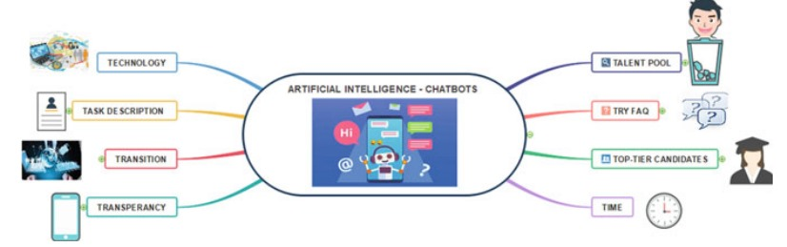

Figure 2.2: Implementation of Interview Chatbot by NLU

|  |
| --- |
|  |
|  |
|  |  |

  CMRCET B. Tech (CSE) 11

**CHAPTER 3**

**RESULTS AND DISCUSSION**

|  |
| --- |
|  |
|  |
|  |
|  |  |

  CMRCET B. Tech (CSE) 12

Chat KCR-Your AI Interviewer For Technical/HR Brilliance

**CHAPTER 3**

**RESULTS AND DISCUSSION**

**2.3.3 Results & Discussion**

* The existing systems focuses building model from Scratch(from Tokenizing, Cleaning, stemming , Parts of speech tagging, finding term frequency of each word and then comparing it with the available competency levels and finally giving the best matched competency level to the user.
* One of the existing system focuses on understanding the intent of user (Natural Language Understanding) and retrieving information (regarding user’s intent) from the model/database.
* The existing system focuses on minimizing work of HR and checking competency levels, none of the solution focuses on making candidate aware of how interview goes.

.

|  |
| --- |
|  |
|  |
|  |  |

  CMRCET B. Tech (CSE) 13

Chat KCR-Your AI Interviewer For Technical/HR Brilliance

CHAPTER 4

**CONCLUSION**

CMRCET B. Tech (CSE) 14

Chat KCR-Your AI Interviewer For Technical/HR Brilliance

**CHAPTER 4**

**CONCLUSION**

**The Problem:** Many job seekers lack awareness of the interview process, leading to inefficiency and uncertainty in their job hunt.

**Our Solution:** Enter the AI Interview Chatbot, a groundbreaking tool that educates, guides, and prepares candidates for interviews. It offers personalized, efficient, and equitable interview experiences.

**The Impact:** Our chatbot empowers individuals with interview awareness, providing tailored guidance.

CMRCET B. Tech (CSE) 15

Chat KCR-Your AI Interviewer For Technical/HR Brilliance

CHAPTER 5

**REFERENCES**

CMRCET B. Tech (CSE) 16

Chat KCR-Your AI Interviewer For Technical/HR Brilliance

## REFERENCES

1. Joko, Siswanto & Suakanto, Sinung & Andriani, Made & Hardiyanti, Margareta & Kusumasari, Tien. (2022). Interview Bot Development with Natural Language Processing and Machine Learning. International Journal of Technology. 13. 274. 10.14716/ijtech.v13i2.5018.
2. Manasa J, Anu Revamma Parvathi "A Study on Future of Artificial Intelligence - Chatbots in HR" Published in International Journal of Trend in Research and Development (IJTRD), ISSN: 2394-9333, Conference Proceeding| ESMRP-19 , September 2019 Available at URL:

http://www.ijtrd.com/papers/IJTRD20772.pdf.

1. H. R., Swapna & Arpana, D.. (2021). Chatbots as a Game Changer in E-recruitment: An Analysis of Adaptation of Chatbots. 10.1007/978-981-16-0666-3_7.

CMRCET B. Tech (CSE) 17